EDI in Engineering Module

Lecture 3 Notes - Disability and Neurodiversity / Systematic Inclusion – Guest Lecturer

Speaker: Jenny McLaughlin - she/her – has ADHD & Dyslexia
Project manager for aviation and infrastructure projects at Heathrow, and lead for disability network at Heathrow. Her aim is to make sure EVERYTHING is accessible, throughout the supply chain and the process of flying at Heathrow. This includes Heathrow college, which has a focus on getting SEN learners into employment. Winner of a WES (Women’s Engineering Society) Top 50 Women in Engineering Award.

Defining Neurodiversity and Disability
What is Neurodiversity – everyone’s brains are wired differently, your brain is as unique as your fingerprint.
Neurodivergent – the edges of the bell curve – where the brain is different from the average. The world is designed for the centre of the bell curve, and is therefore harder for neurodivergent people to interact with. Examples include autism, dyslexia, ADHD, etc.
“nobody is less than” “nobody is broken” therefore we need to be making sure we’re not making barriers for those who are wired differently. Neurodivergent brains may find some “typical” things difficult but may also function with greater strength than a neurotypical brain in other areas.
We all experience process and communicate differently, and have different strengths, but may need to put different strategies in place in order to achieve ‘executive functioning’. Examples of ‘executive functioning’ include:
- Working memory
- Self-monitoring
- Planning and Prioritisation
- Task Initiation
- Organisation
- Impulse Control
- Emotional Control
- Flexible Thinking
Examples were given:
- Jenny is weak in working memory and she has developed strategies as a result, e.g. writing tasks down immediately
- Self monitoring; how you interact and socialise. Some individuals are unaware of their actions in social settings, i.e. they can come off as rude or blunt.
- Task initiation can be easy for some people, others need help to break that down into smaller chunks. Buddying is a good way to stay on task.
- Impulse control – Jenny will see something on her phone and buy it immediately without thinking. Jenny makes connections that other people have ruled out. Innovation within engineering can come from people with poor impulse control because they haven’t ruled things out.

Co-regulation; if you’re working with individuals who struggle with impulse/emotional control the calmer you can keep yourself the more likely it is that people around you will remain calm. Part of this can be about reacting to the root cause of an issue someone is experiencing rather than the behaviour it is causing them to exhibit.
Accessibility is often to be assumed to be about wheelchair users, but it is much more broad than this. It can be as simple as not being able to reach something on a top shelf. As an engineer when we experience a barrier, or witness someone else experiencing a barrier, we need to stop and consider what could be done about this barrier. If a fire door is too heavy for someone to open, then in a fire they may die.

Designing for Inclusion
Definition of inclusive design:
There are many different definitions (see Google, Design Council, British Standards Institute, Heathrow, etc.)
Principles of inclusive design:
- People centric
- Acknowledges differences
- Offers choice
- Provides flexibility in use
Disabilities change over time and can be temporary or situational
Designing right first time has 3 aspects; Build – Operate/Maintain – Access/Use. Some examples are given:
  - Can it be inclusively built? Is the design allowing for this? CDM Code – Construction Design Manufacture – most of this is based on the male white average. Jenny is unable to take on most of the tasks safely as result. This is a barrier for women in engineering.
  - Inclusively operated & maintained – i.e. CCTV cameras across Heathrow are in awkward places. There are some areas where an individual needs to be 5ft 8in to maintain. That is a barrier and makes it inaccessible to maintain. Another barrier is holding your arms over your head. This can be inaccessible to ageing engineers.
  - Inclusively accessed and used.

Designing for everyone: see image, all of these things need to be taken into account:
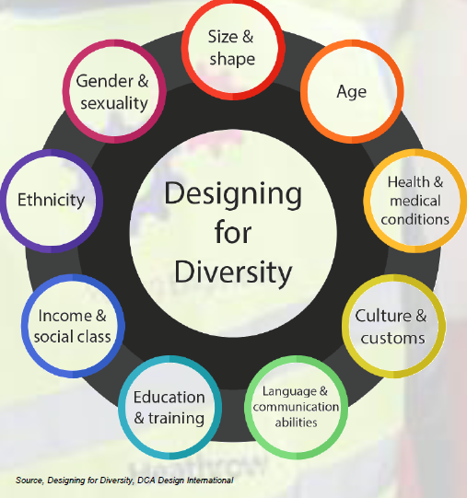
Human abilities and experience are very variable, this might include:
- Mobility / Size / Height
- Visual / Auditory (both processing and intake)
- Cognitive
- Taste
- Smell
- Metabolism
- Balance (proprioception, texture, inner ear, visual interpretation of surface)
- Orientation (what is the narrative of a building?)
- Touch

Human diversity;
An example is given from Criando Perez – Invisible Women, women are 75% more likely to die or be injured in a car crash than men because the crash test dummy which cars have been designed around is based on a 5’ 8” male.
PPE is designed around the facial features of a Caucasian face. Fighter plane seats were designed for the average pilot and resultingly fit none of the actual pilots.
Fire escapes, better to have an image, a direction and words in order to make it understood by all users. Colour and placement are also important though, especially for considering colour-blindness or other visual impairments.
“You can’t say, you can’t play”
As engineers we want everyone to be able to participate. We don’t want to say to anyone “you can’t play”. Typewriter was invented so someone losing their vision could write love letters. Facetime comes from the deaf community wanting to be able to sign to each other on the phone.

Reframing disability
Barriers aren’t just experienced by one section of the community and can vary in space and time:
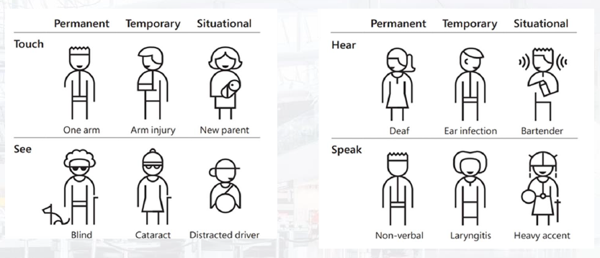
Standards and guidance exist to support inclusive design. The minimum standard is part M of the Building Regulations. But there is also British Standards (BS 8300, PAS 6463), RIBA Inclusive Design Overlay, and employers EDI strategies. Heathrow has both the Accessible and Inclusive Airport Asset Standard and their report “Open to All” (which tells us that 34% of travellers require some support).
Inclusive design is Good Design – for example the redesign of the fire extinguisher pull pin which was done for inclusion reasons but was find to be a better solution for ALL users.
Hergonomics – tools specifically designed for women. Also finding many men are buying as they find it’s better for them too (e.g. smaller than average hand size, lower than average strength).
Examples of inaccessible designs – COVID & pregnancy tests…how do you know the outcome if you are blind? Slide deliberately shared with difficult to read text.

Recommendations:
Be curious and notice what is and isn’t working for people. Why and what could you do to fix it?
Question the standards, the data and the assumptions
Use accessibility checkers
Make your designs flexible
Give safe space for feedback and conversations
