## Applicant Quick Guide

Worktribe Ethics – Application/Amendment

## 

## Study Status

The status bar allows you to follow the different stages of the application process.

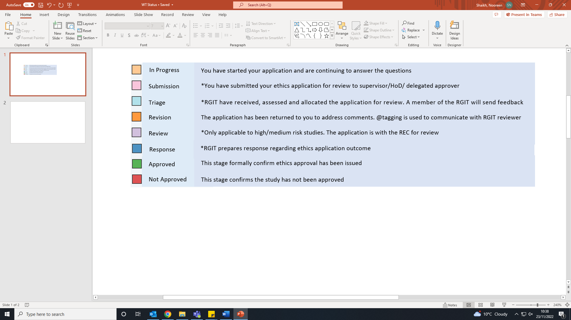

*The application is uneditable by the applicant or other editors.

# How to create a new ethics application

## Create a new application

1. Hover over the Ethics menu and click ‘Create Application’. A pop-up window will appear (allow pop-ups).

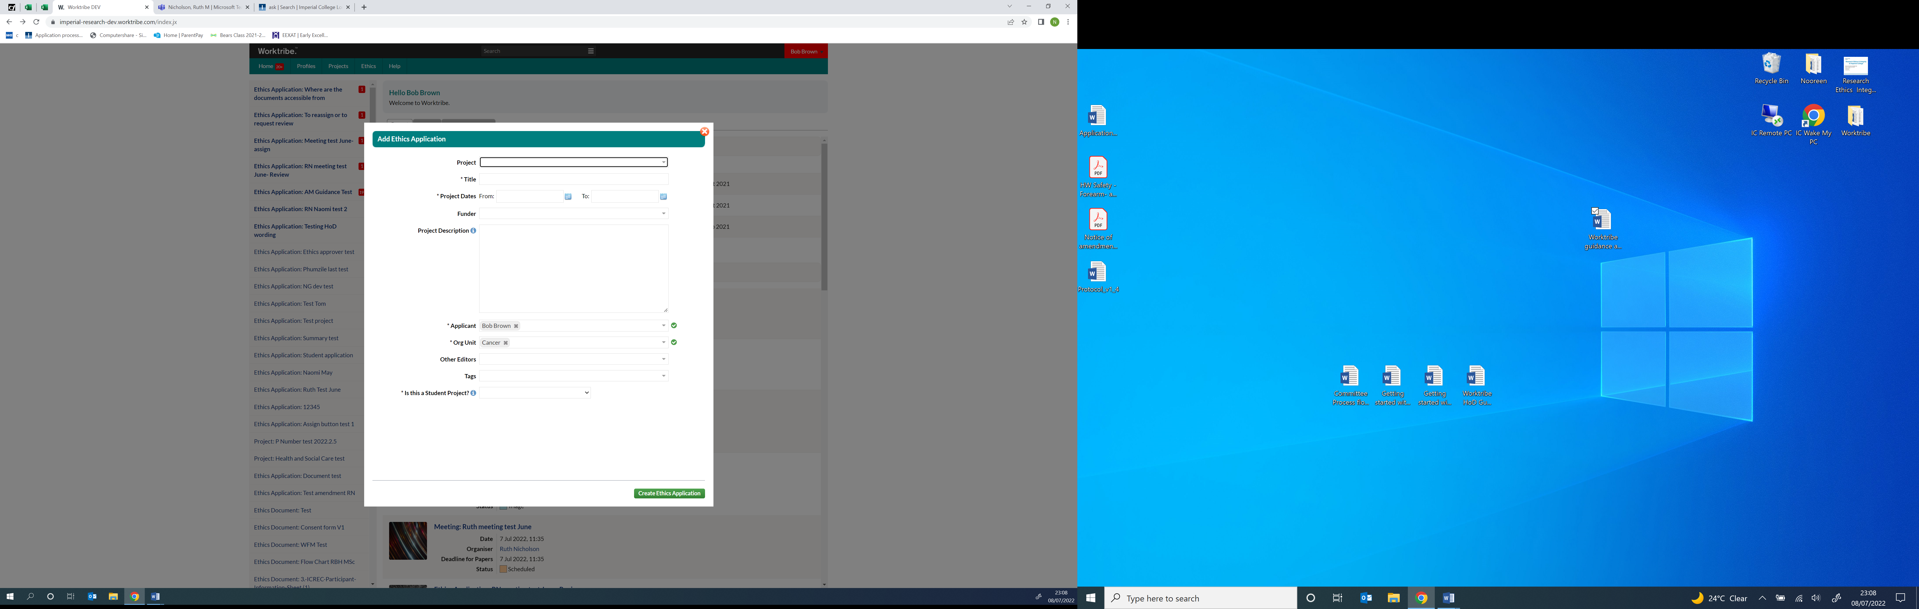

1. Click create ethics application button. The status of the study will change to in progress by you status.

## Completing the application question tabs

1. Complete the tabs. Questions are generated according to how you answer.

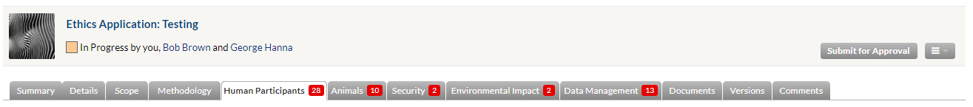

1. Upload supporting documents: Use the online templates. **drop-down menu button,** click on **Template** and select **download**. Upload completed documents to the Documents tab.

## Supervisor / HoD approval

1. Approval by Supervisor/HoD: Click submit for approval button to send the application to your HoD/ Supervisor (if required) for review. Status will change from ‘**In progress’** to ‘**Submission**’**.**
2. **After HoD approval the application it is available to RGIT for triage.** Study status ‘**Submission**’ to ‘**Triage’**.
3. *Resubmission to Supervisor/HoD: If not approved the application is returned and you will need to address the comments and resubmit back to the Supervisor/HoD.*

# Review of ethics application

Once HoD/Supervisor approval is given, the RGIT will be notified, and you will be notified of the Research Governance Facilitator (RGF) who has been assigned your study.

## ERGC triages and reassign application

Your notifications will update to show your application has been **Triaged by the Ethics Coordinator.**

### High risk studies

If the study is deemed high-risk, the application goes through the normal review process. The only additional step involves Committee review and any revisions they request/suggest. You will receive a date for the meeting (the PI will be required to attend), where any ethical issues will be discussed.  
If during the review process your low-risk study is subsequently found to be high-risk, the study will at that time point be deemed to require committee review and you will be informed of the outcome.

# Revision of the ethics application by researcher

## Revision of online application tabs

1. **Once the RGF has reviewed your application, they will transfer this back to you. Open** the study. **Click** on the **speech bubble icon** to view all the comments. Each section needs to be reviewed; any questions/clarifications raised can be responded to by adding a comment directly next to each individual question.

## Revision of supporting documents (Protocol, PIS ICF)

1. All supporting documents requiring revisions: use **track changes** to edit and add comments directly in the word documents.
2. Upload all revised documents by replacing the current version in the Documents tab.
3. Once ALL the revision/clarifications have been completed, notify your assigned RGF by @tagging them.

***Note: Every time you are @tagged or you @tag someone into a comment a system notification and email are generated.***

# RGF and Head of RGIT final review

## RGIT final review

The RGF will review the revised application, documents, and your comments. Once all changes have been made successfully, and the conditions of approval confirmed according to the Head of RGIT, the RGF will @tag with a comment notifying to ‘**Resubmit for approval**’.Clickresubmit for approval button**.**

## Supervisor/ HoD approval of the application

**Revision Submission**: Resubmit the final revised application to your Supervisor/ HoD. the application has been submitted for submission approval message. Study status will change to ‘**Revision Submission**’.

**Note:** RGIT approval cannot be issued until final Supervisor/HoD approval is received.

On Supervisor/HoD approval the status will change from **revisions** **submission back to Triage.**

# Response/ Approved

Once the study has gone through its initial approval. The status will appear as approved status

The **approval letter** will be available to download from the documents tab and the RGIT will confirm with the approval conditions**.**

# Post approval responsibilities (Amendments)

## Creating an amendment

Your ethical approval is based on the online ethics form and supporting documents you originally submitted. If a change is made to your original ethics submission and you do not notify the RGI team, then your ethics approval may become invalid.

An amendment can be started by clicking amend button.

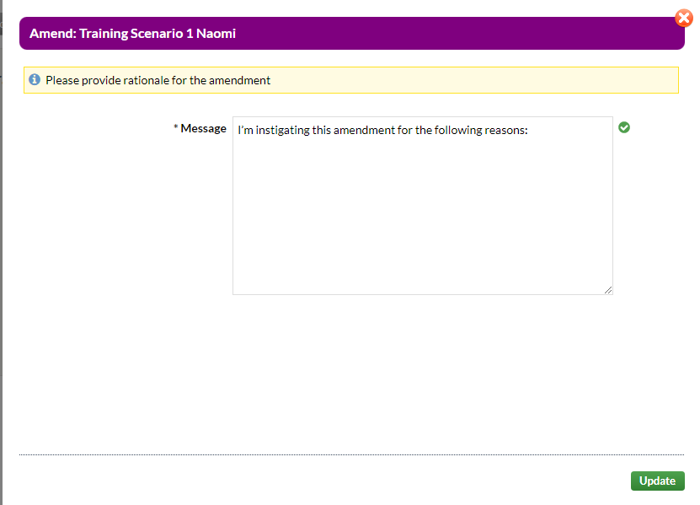

**Include a summary** of the changes being made to the study and why. The status will change from the study being approved to Amendment by you status.

## Update the online application tabs

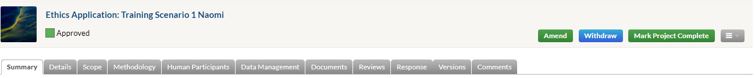

Edit/make any changes to any of the questions, you will need to update all relevant sections.

## Updating the supporting documents.

If any documents require updating then make changes usingtracked changes before uploadingthe new/reviseddocuments to the documents tab.

*NB. Amended documents should be labelled as the next versions and dates from the current versions. **The original approved versions should not be replaced.**

**You will also need to complete and upload the Notice of Amendment Form (Worktribe) which can be found at** [**https://www.imperial.ac.uk/research-ethics-committee/application/post-approval/**](https://www.imperial.ac.uk/research-ethics-committee/application/post-approval/)**.**

Once all the updates to the application are complete press submit, the amendment will automatically be sent to the Supervisor/ HoD for approval. The status will change to ‘**Amendment Submission’**.

## Supervisor / HoD approval

The initial Supervisor/ HoD approval process is the same as previously described.

The study status will change from in ‘**Amendment** **submission**’ to ‘**Amendment** **triage.**

# Review of amendment

## Amendment triage

The amendment will be triaged in the same way as the original ethics application. Your home page will update to show the amendment is triaged. Amendment triage by ethics admin status

## Amendment review by RGF

This will follow the same process as described above of reviewing the amendment making any revisions as requested by the RGF and Head of RGIT Final Review.

# Resubmit amendment for approval

After you are ready to submit the final revised application for approval **select** Resubmit for approval button**.**

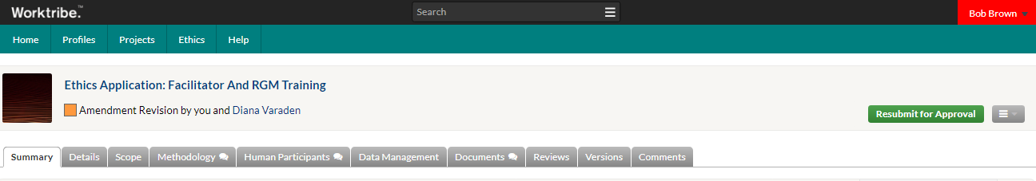

## Supervisor/ HoD approval of the amendment

After your supervisor/HoD approves the application, the status will change from ‘**Amendment Revision Submission**’ to ‘**Amendment Triage**’.

# Response/Approved

Once the study has been approved by RGIT a notification alert will appear advising that the approval letter is ready to be accessed from the documents tab.

# Annual Progress Report (APR)

This [Annual progress report [Word]](https://www.imperial.ac.uk/media/imperial-college/research-and-innovation/imperial-college-research-ethics-committee/public/6.-Annual-Progress-Report.docx) document must be uploaded to the documents tab and a notification sent to the [Ethics and Research Governance Coordinator](mailto:rgitcoordinator@imperial.ac.uk) (ERGC) within 30 days of the anniversary of a project being granted ethics approval.

If a study is completed within a year of first obtaining ethical approval, an End of Study Notification must be submitted instead.

# End of study ( EoS) Notification

This [End of study notification [Word]](https://www.imperial.ac.uk/media/imperial-college/research-and-innovation/imperial-college-research-ethics-committee/public/7.-End-of-Study-Notification.docx) and an [End of study summary report [Word]](https://www.imperial.ac.uk/media/imperial-college/research-and-innovation/imperial-college-research-ethics-committee/public/End-of-Study-Summary-Report.docx) must be uploaded to the documents tab and a notification sent to the ERGC. If you do not submit an End of Study report or extend the study end date with an amendment, your study will be assumed to be closed, and ethics approval will cease.

You must notify the RGI team when your study has ended; within 90 days by email of the termination of your study or when the practical research activity ended. The notification must be supported by an end of study summary report.