iLab Booking Instructions
- Once you have signed into your iLab account, click on the “Schedule Equipment” tab.
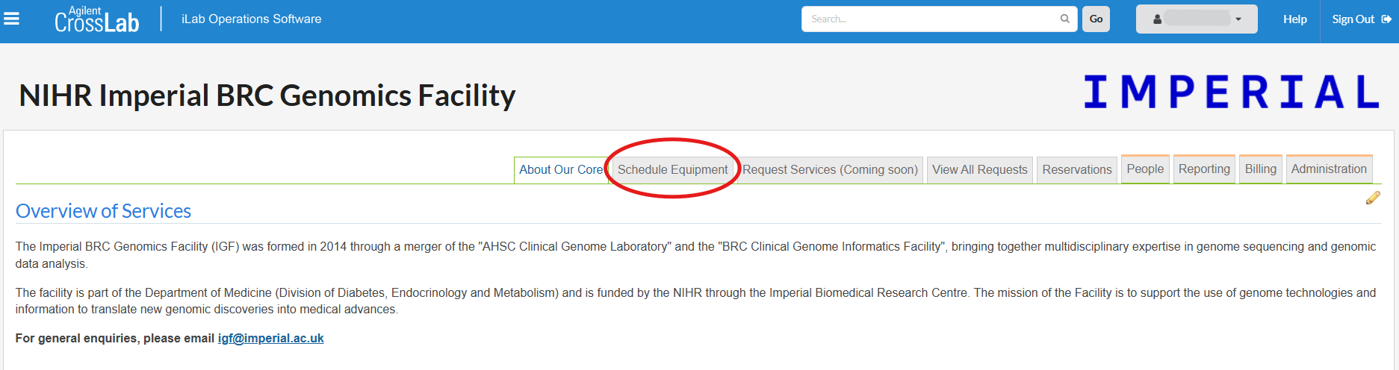
- Locate the instrument or workspace you would like to book from the list then click “View Schedule”
Example: 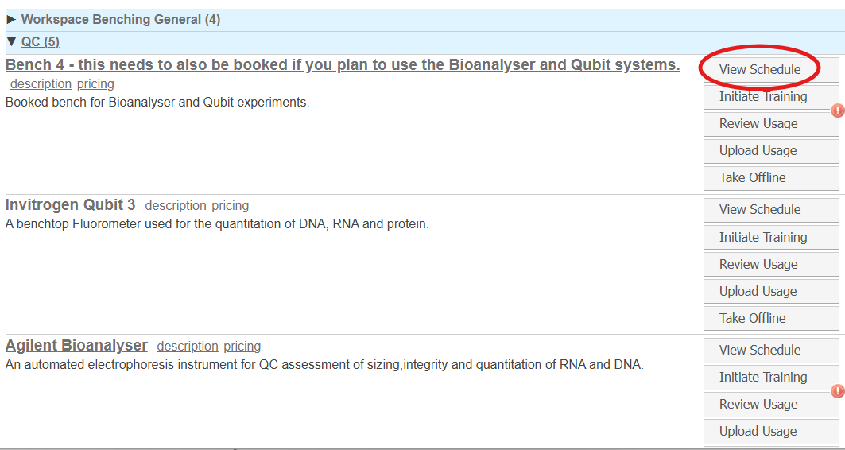
- On the calendar, double click the timeslot you would like to book.
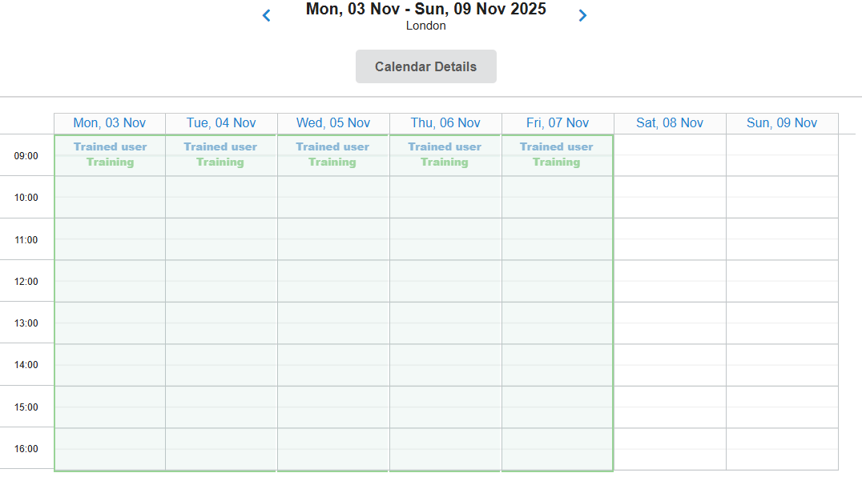
- Complete your booking on the “Create Reservation” popup.