MICROAGGRESSIONS TOWARDS WOMEN IN STEM, FOCUSED ON GROUP PROJECTS
Lesson plan intended for undergraduate students at Imperial College London. No specified year level but recommended to be implemented at the beginning of a course/module/group project.

Intended Learning Outcomes (ILOs):
By the end of the session, students will be better able to:
- Recognise cases of gender microaggressions in group work towards women in STEM
- Recognise the effects of gender microaggressions towards women in group work.
- Learn strategies for allyship in group work situations

Schedule:
Topic | Activity (Timing)
Introduction: What is a microaggression? | - Introduction ask students what a microaggression means  - Give a definition  (~5 min)
Present Examples of Microaggressions | Put students in smaller groups (3-5 students) to discuss  - (5 min) For groups to come up with examples of microaggressions and groups share responses based on discussion  - (10 min) Show MentiMeter with responses from Women in Mecheng lunch
Show Interview Video | (~5-10 min) Only show key parts and link video for student who want to refer back to it.
Effects of Microaggressions | - (10 min) Talk about the themes in microaggressions and the effect these have on the victims  - Talk through one example as done in images below from Kim and Meister research [article 2]
What can we do to minimize these incidents | - (~3 min) Get student opinion if any of the examples shown were surprising.  - (5 min) Get student ideas on how to minimize these incidents  If more time, points above can be discussed in same small groups as second topic  - Introduce Code of Conduct addressing equality and fair treatment to others  - Show example [other 2]  - Show Nolan Principles [other 1]

Content and Topics:

What are microaggressions
- Distinguish between micro and macroaggressions
  - “Microaggressions focus more on interpersonal behaviours compared to sexism which focuses more on general attitudes about gender dynamics.”
  - Give example of micro vs macroaggression
    - Macroaggressions are behaviours known to be inappropriate
      - Ex. Commenting on women’s physical appearances, name-calling individuals.
    - Microaggressions are more subtle, perpetrator is not necessarily acting with malicious intentions
- Types of microaggressions
  - Devaluation of technical competence
  - Devaluation of physical presence
  - Denial of One’s reality
  - Pathologizing woman’s personal character
  - Pathologizing woman’s gender
- Distinguish between micro and macroaggressions

Effects and consequences of microaggressions
- Attacks sense of belonging [article 3]
  - Belonging impacts everyone environments where everyone is celebrated improves everyone’s experience
- Build empathy through lack of belonging. Even if you have not been marginalised because of gender before, everyone has likely felt outcasted in some context.

What can we do?
- Create a code of conduct set expectations from the beginning of degree/project
- Create respect within groups based on interview and experience running DMT by Dr. Marc Masen.
- Examples of codes of conduct and how they can be implemented in different scenarios
  - Project plans
  - Previous to lab work
  - Teambuilding activity

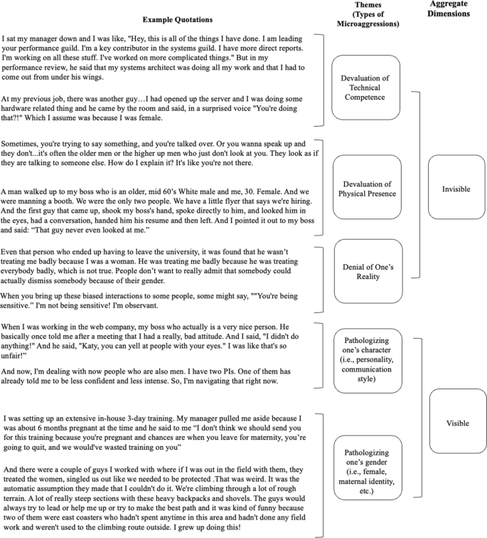
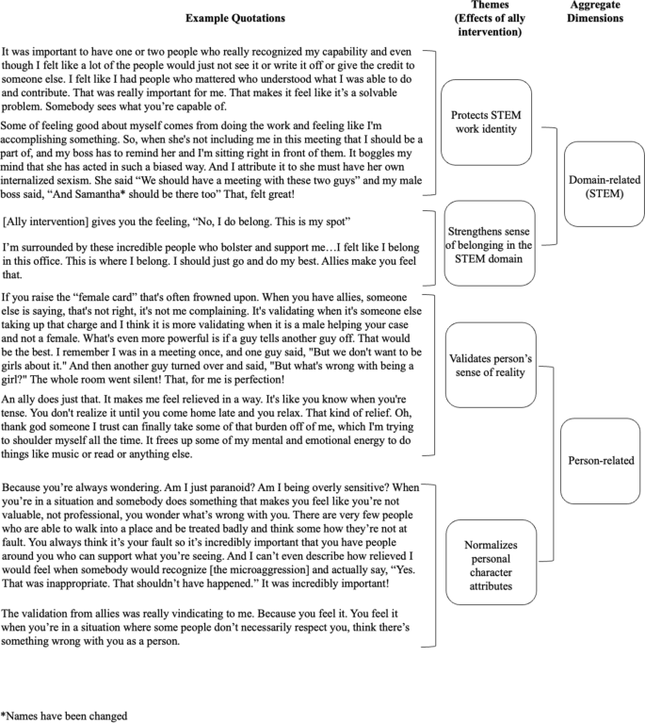

Reading List:

Articles
- Causes of microaggressions
  - Monnica T Williams
  - https://academic.oup.com/book/28752/chapter-abstract/234466251?redirectedFrom=fulltext
- Microaggresions, Interrupted: The experience and effects of gender microaggressions for Women in STEM
  - Jennifer Y. Kim & Alyson Meister
  - https://link.springer.com/article/10.1007/s10551-022-05203-0
- Implementing diversity training targeting faculty microaggressions and inclusion: Practical Insight and Initial findings
  - Ellen Ernst Kossek ekossek@purdue.edu, Patrice M. Buzzanell, and Ankita Nikalje
  - https://journals.sagepub.com/doi/full/10.1177/00218863221132321
- The power of interest: mironitized women’s interest in engineering fosters persistence beliefs beyond belongingness and engineering indentity
  - Dina Verdín
  - https://stemeducationjournal.springeropen.com/articles/10.1186/s40594-021-00292-1

Reports
- “Girls in the Physics Classroom”
  - Institute of Physics Report
  - https://www.iop.org/sites/default/files/2023-02/Girls-in-the-physics-classroom-a-teachers-guide-for-action.pdf
- “Opening Doors: A guide to good practice in countering gender stereotyping in schools”
  - Institute of Physics Report
  - https://www.iop.org/sites/default/files/2019-02/opening-doors-countering-stereotyping.pdf

Books
- Inferior: how science got women wrong - and the new research that's rewriting the story
  - Angela Saini
- Invisible Women
  - Caroline Criado-Perez

Other
- “The Seven Principles of Public Life” (Nolan Principles)
  - UK Government
  - https://www.gov.uk/government/publications/the-7-principles-of-public-life/the-7-principles-of-public-life--2
- Code of Conduct and Values Example
  - https://osf.io/mdh87/wiki/Code%20of%20Conduct%20%26%20Values/
  - https://www.big-data-biology.org/manual/

