Visual Guide for The Invention Rooms
This guide has been made to help you prepare for your visit to The Invention Rooms.
We have tried to include as much as we can to help you understand what to expect. If you have any questions that aren’t answered in this guide, please email whitecity.community@imperial.ac.uk

This is The Invention Rooms. It is in White City and close to the Imperial College London campus. You will be coming here for your event.
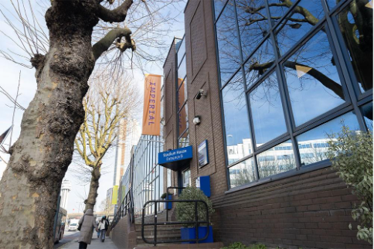
Alt text: A brown-brick building with big windows. Trees line the pavement, and there is an orange flag that says ‘Imperial’ in bold letters. A sign over the door says ‘Stadium House: Entrance B’.

These are some of the people you might see when you come to The Invention Rooms. They work in the building. They are all very friendly, and you can talk to them if you need help while you are here.

Alt text: Six people standing together inside The Invention Rooms. They are all smiling at the camera.

There are lots of other people that work here too, so you might see other groups of people in the building during your event.
When you arrive for your event, go to Entrance B. You can use steps or a ramp to get up to the door. Press the bottom buzzer. In the photo below, it is the button with the red circle around it.
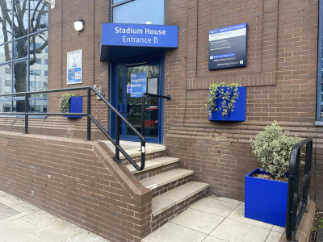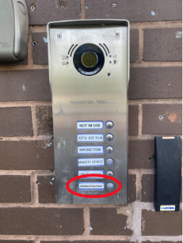
Alt text (left image): A blue door with steps and a ramp leading up to it. Over the door is a sign that says ‘Stadium House: Entrance B’. There are plants in blue boxes around the entrance.
Alt text (right image): A silver panel with multiple buttons and a microphone on it. There is a red circle around the bottom buzzer, which says ‘The Interaction Zone’. This is the buzzer you need to press.

When rung, the buzzer makes an intermittent, high-pitched tone for a few seconds.
When you have pressed the buzzer, someone will come and let you in. It might take them a few moments to get to the door!
You’ll then go into a reception area where you might be asked to sign in.

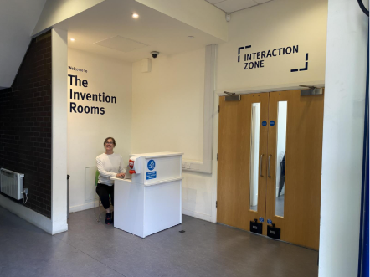
Alt text: A white walled hallway with writing on the walls that says ‘The Invention Rooms’ and ‘Interaction Zone’. There are wooden double doors, and a white desk where a member of staff is sitting and smiling.
The person who let you in will then direct you to the event room, which is on the right. It is all on one floor, so you don’t need to climb any stairs.
There are two event spaces at The Invention Rooms. The main space looks like this. It might look different depending on what type of event you are coming to.

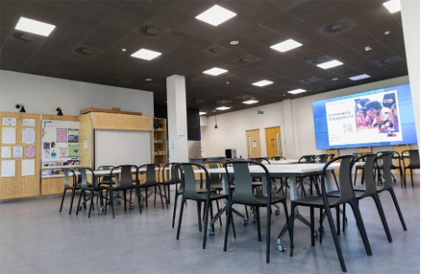
Alt text: A big, modern-looking room with a grey floor, white walls and some wooden shelves. There are a few tables and chairs set up in the middle of the room.
There are lots of things you can do at The Invention Rooms. You might listen to a talk, have a meeting or take part in a workshop.
There is free drinking water available in the main space.

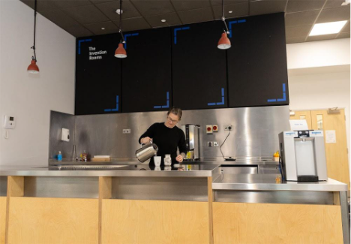
Alt text: A metal and wooden space with a water fountain and kettle in the corner of the main event space. A member of staff is making a cup of tea.
You might hear low background noises from the fridge, ice machine and hot water urn.

There is also a meeting room, which has a hearing loop.
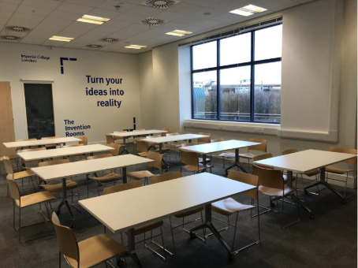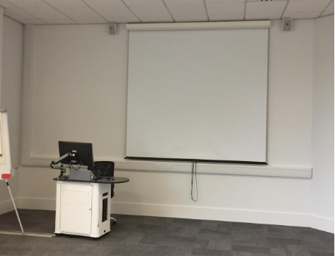
Alt text (left image): A medium-sized meeting room set up with rows of chairs and tables. There is a big window, and a sign on the wall that says ‘Turn your ideas into reality’.
Alt text (right image): A different angle of the meeting room which shows a big screen, and a small desk with a computer.

There are two sets of toilets at The Invention Rooms. There are 5 gender neutral toilets inside the event room. We also have one accessible toilet with baby change table and 3 single closed cubicles next to the entrance doors.
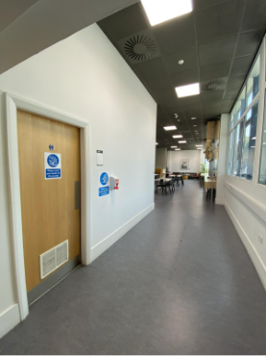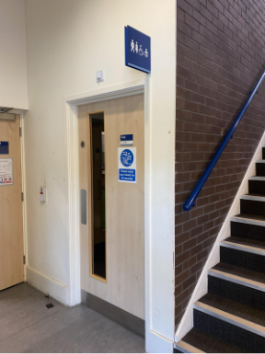
Alt text (left image): A wooden door in the corner of the main event space with a toilet symbol on it in blue.
Alt text (right image): A wooden door with a toilet symbol above it in blue. It is next to a set of stairs.
You might hear hand dryers, and sometimes air fresheners beep, followed by a spraying sound.

If you need to go somewhere quiet during your event, please talk to someone who works here, and they can open an additional room for you.
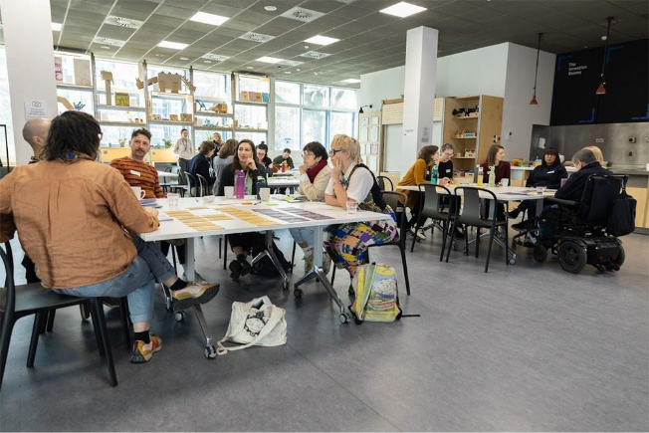
Alt text: Three groups of people sitting around three tables in the main event space. They are all talking to each other.

The Invention Rooms is only open when you have already told us you are going to come here. You cannot come if you haven’t registered for an event that is happening here.
We are looking forward to welcoming you to The Invention Rooms, and we hope you’re excited to be coming!
If you have a question that this guide hasn’t answered, please send us an email at whitecity.community@imperial.ac.uk

