
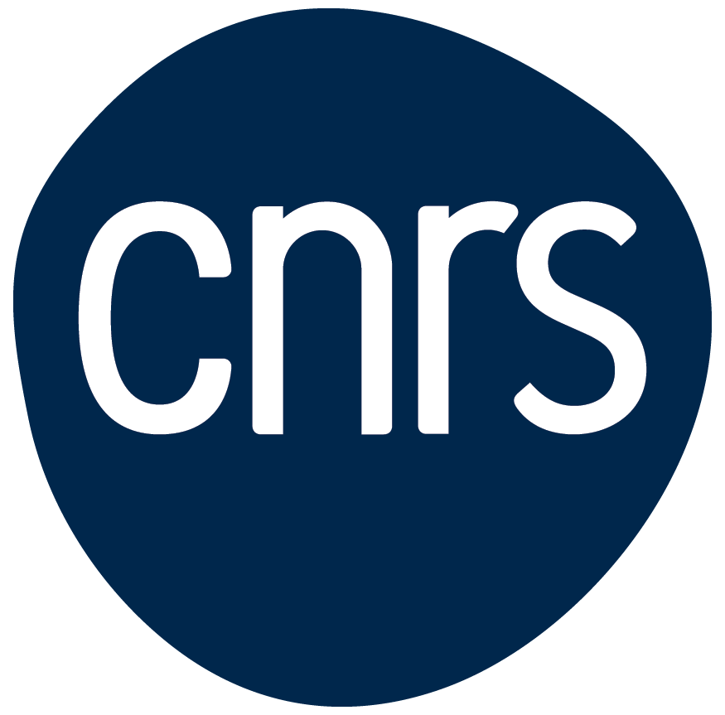

CNRS - Imperial PhD joint programme – 2026 Call for projects: Quantitative Science and Engineering for a Sustainable World

Imperial and the Centre National de la Recherche Scientifique (CNRS) recognise that collaborative international activities enable cross-border pooling of research capabilities and sharing of expertise and facilities, the opportunity to appreciate different perspectives, outputs that are typically more highly cited, as well as access to new environments for impact and exploitation of research outcomes.
CNRS and Imperial are launching a seventh joint call for collaborative PhD proposals between the two institutions. The theme for this year is ‘Quantitative Science and Engineering for a Sustainable World.’
Particular emphasis will be placed on projects contributing towards addressing SDG-related challenges such as watercycle and the energy transition, using mathematical and/or engineering approaches.
Examples of research themes include, but are not limited to:
- Future technologies.
- Transport of people and ideas.
- Resilience and risk mitigation.
- Systems approach to support the built and natural environment.

The aim of this Call is to develop collaborative PhD projects that can train and network the next generation of researchers and innovators, offering them expertise not available at just one institution, and to also seed Imperial-CNRS collaborations that can lead to Horizon Europe and other funding opportunities.
Imperial and CNRS now have 30 collaborative projects and 60 PhD students registered with the collaborative PhD programme, working on high-impact UK-France projects.
This call invites Principal Investigators at CNRS and Imperial to jointly put forward a research project to be underpinned by x1 PhD at CNRS and x1 PhD at Imperial, which includes joint supervision plans and a built-in mobility programme. Support for CNRS-Imperial cohort-building activities and relevant training will also be provided each year.

Strategic rationale

CNRS is Europe’s largest fundamental science research organisation and have 1,100 research labs in France and abroad; a budget of 4.2bn Euros; 33,000 staff dedicated to research. Imperial and CNRS researchers have co-authored 2,919 publications in the past five years (2020-2025) and have 31 collaborations thus far in Horizon Europe.
The CNRS-Imperial International Research Centre (IRC) for Transformational Science and Technology, launched in April 2022, is deepening and expanding connections between our two institutions to address UN Sustainable Development Goals.
Formal collaborations under the IRC umbrella are:
- International Research Lab Abraham de Moivre (Mathematics)
- International Research Lab Ayrton Bleriot Engineering Lab.
- International Research Project Integrative Metabolism.
- International Research Network Quantum Fields and Strings
- International Research Network GOLDMINE (neuromorphic sustainable computing).
- International Research Network LhARA (physics for medicine/novel laser treatment for cancer).
- Joint PhD programme
The €95.5 billion Horizon Europe budget, which runs from 2021-2027, provides continued impetus for joint scientific discovery and innovation.

Call guidelines

Eligibility
- Scientists from Imperial who can supervise PhD students;
- Scientists working in a research lab affiliated to CNRS holding an accreditation to supervise PhD students (HDR)
- A PI cannot submit more than one application in the framework of this call.
There must be one PI from Imperial and one PI from a CNRS laboratory. Those who do not already have a collaborator may consult Imperial’s website or the CNRS website to find information on the research groups and projects being carried out in either institution and/or contact the IRO at Imperial or DEI at CNRS for support in identifying potential collaborators.

Funding
The model is for each collaborative project to have two PhD students and two supervisors, one of each at both Imperial and CNRS.
At CNRS the funding will be for a three-year studentship. Funds will include mobility costs for visits to London for the project over three years.
At Imperial, 50% of the funding for the three-year studentship (Home fee + UKRI London stipend) is allocated centrally, and additional funding of £2500 is provided for mobility. The remaining 50% of the studentship must be allocated by the Imperial PI’s department or other funder (eg CDTs, DTPs, or other research groups, external funding). If a PI has more than 50% of the funding to contribute, then anything not needed for the studentship can be used for additional mobility, consumables, or other related costs to support the project. Given that 50% co-investment is required to apply, Imperial applicants must submit confirmation (an email is sufficient) of funding for 50% of a studentship from the person who is responsible for the funding source of the studentship e.g if using a department studentship allocation then submit a note from the HoD or similar, if using a CDT studentship then submit a note from the Imperial CDT lead, if industry funding, a note from the relevant person at Imperial or the industry partner, etc.
Number of awards
Up to four projects are expected to be funded jointly by Imperial and CNRS.
Support period
3 years

Deadline and start dates
Open date: 8 December 2025

Closing date: 23 January 2026
Notification date: March 2026
Beginning of the projects: October 2026

Evaluation
Proposals will be evaluated and ranked by an Imperial-CNRS committee according to the following criteria:
- Does the proposal clearly engage with the call topic for this year.
- Scientific quality & originality of the project
- Scientific merit of the teams
- Synergy between the teams, added value of international cooperation
- Convincing plan for engaging PhD students in the research and for managing joint supervision
- Projects are likely to be sustainable beyond the grant period. (The proposals should also include an outlined plan for raising external competitive funding.)
- Benefit to researcher based on her/his career stage

For additional context, the focus areas of the IRC are identified in the below chart.

c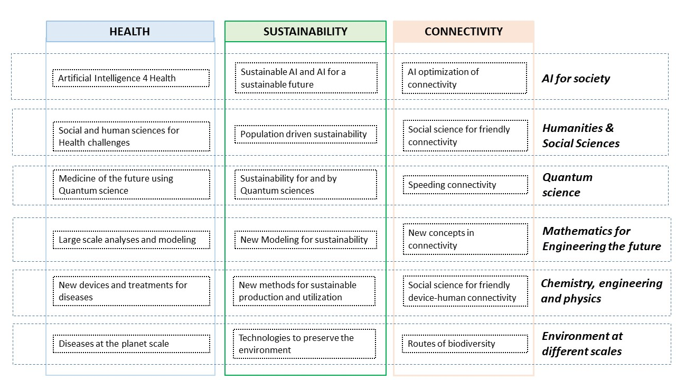

How to apply
Imperial applicants should submit in electronic format (Microsoft Word or Adobe PDF) to globalseedfunds@imperial.ac.uk;
CNRS applicants should submit the same file via the dedicated platform: https://noa.cnrs.fr/#/accueil (as several PhD Joint Programs are currently open for proposals, please make sure you select the correct call).

Administrative and technical support

Imperial IRO: Ms. Heather S. Kerst, h.kerst@imperial.ac.uk

CNRS DEI: Mr. Carl Ialamov, carl.ialamov@cnrs.fr

Imperial-CNRS Joint PhD Project
APPLICATION FORM

This form must be completed using 10pt Arial font. Margins must not be adjusted. Where the form has been adjusted or incorrect font used, the proposal will be returned to the applicant without further assessment.

The joint proposal must consist of the following parts, in one single file (up to 5 pages, not including parts I, J and K)

- Title Page
Name of Imperial Principal Investigator | Department
Current position  (Note that applicants must be permanent members of academic staff) | If you are a member of a Centre or Network, please provide Centre/Network name here

Name of Imperial Co-investigator (if relevant) | Department
Current position | Institution
(duplicate co-investigator section as necessary)

Partner details
Name of CNRS Principal Investigator | Laboratory
Current position | Email address
(duplicate CNRS partner section as necessary)

- Lay description of the scientific project
Title
Guidance: lay (accessible to the public) description of the scientific project and its contribution to a research area, historical context of application (if applicable), quality and originality of the project, objectives, scientific methodology, expected results and their meaning, future perspectives. Explain the relation between the project and the research themes of the laboratory.

- Added-value of the international cooperation
Guidance: Describe the added-value of the international cooperation to fulfil the aims of the project (explain why the project cannot be carried out at a national level only). Describe the expected benefits for the UK and French teams. Describe the balance between the contributions of the UK and French teams.

- Plan for engaging PhD students in the research and for managing joint supervision
Guidance: Describe how PhD students be engaged in the research project. How will joint supervision be managed?

- Planned activities
Guidance: Describe the planned activities in the framework of the project and provide a timetable. Explain how these activities will help achieve the aims of the project. This part should include explicit lines regarding the planned travel of the PIs & the PhD students to the other country.

- Sustainability & External Funding
Guidance: Outline the proposed plan for raising external competitive funding.

- Ethics
Guidance: Does the project raise ethical questions? If yes, please describe them and how they are dealt with.

- Benefits to researcher based on her/his career stage
Guidance: Please describe how involvement in this collaborative project would benefit you, given your stage of career?

- Scientific quality of the teams
Guidance: Please attach in annex a list of complete citations of no more than 10 publications related to the project for each team. (This list is not taken into account for the page limit.)

- Short curriculum vitae of Principal Investigators
Guidance: not taken into account for the page limit

- Confirmation of at least 50% of Imperial studentship from Head of Department, Director of Programme, or other relevant authorised person

Guidance: Imperial PIs must provide an email confirmation from their director, head of department or other relevant authorised person to show they have a commitment to use at least 50% of a departmental or other studentship for this programme.

